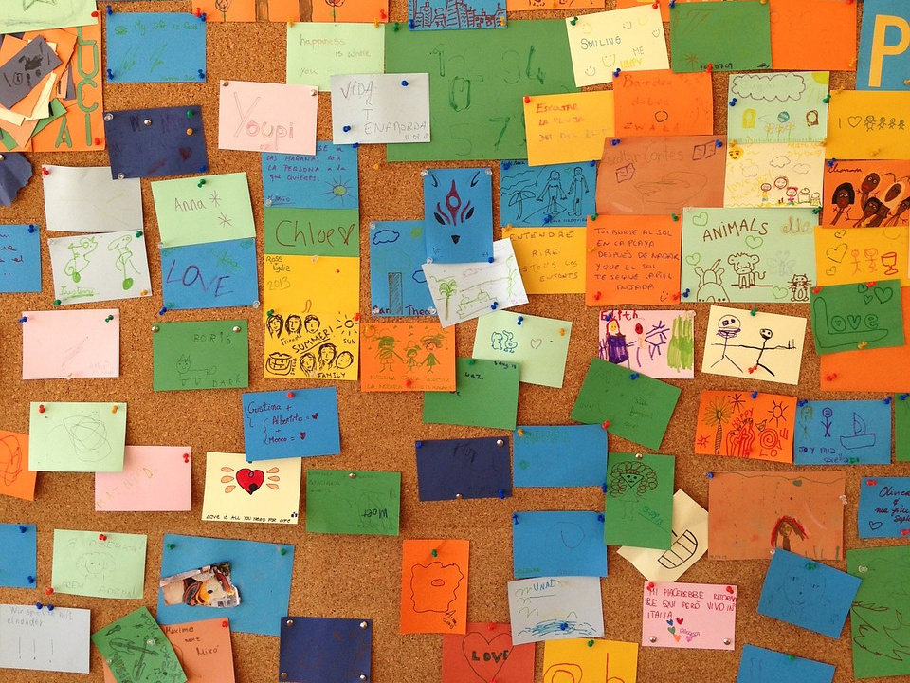
Liberating Structures
Resource Wall
2nd September 2025

Workshop resources/Artefacts
- Today’s Slides
- Today’s Lucid Board

- Slack channel - give and get help from the global LS community

Evaluation Link
If you haven’t filled in the feedback form, please do as it’s super helpful to get feedback on how things went today: https://www.coursecheck.com/event/YEAQFL

Exploring Liberating Structures - Which structure to use for your purpose
- LS Matchmaker Google worksheet
- LS Matchmaker two pager

Add your own resources here <<<
Got a book? Tip? Suggestion?

Structures We Covered Today

Wild/Mad Tea
Video Explanation
Video demonstration
Wild tea party (also know as Mad Tea)
Example from the field
Mad Tea Party Invitations Library
Proposed prompts for Mad Tea plus some icebreakers

Impromptu Networking
Video explanation
Case example face to face video
Article with field examples

TRIZ
Video Explanation
Video Demonstration
Article including field examples
TRIZ template

1-2-4 all
Video explanation
Article including field examples
Riff on 1-2-4 all, 4-2-1 SNAP

Conversation cafe
Video explanation
Video impressions of F2F convo cafe
Video demonstration on line

Spiral
Video explanation
Video demonstration
Spirdemonstration of F2Fal before working video
Spiral is an LS in development inspired by the work of Linda Barry

Troika
Video explanation
Video demonstration
In conversation with Henri talking about Troika, 15% solutions

What, So What, Now What
Video explanation

Further Resources

History, Origins, Background
- LS History video
- Introductory article by Keith
- http://www.liberatingstructures.com/principles/
- Article Liberating Structures should be everywhere people interact
- The Deliberate Irony of Liberating Structures article by Keith McCandless

Prefer to listen than read? Podcasts
- Leadermorphosis podcast interview with Henri & Keith
- Another conversation with Keith and Henri
- Meisha Rouser podcast with Keith McCandless
- Keith on ‘Brave New Work’ Podcast
- Following a Hunch - Podcast with Keith
- Creating Powerful Invitations Podcast

Links to complexity science
- Series of articles by Keith digging into this topic
- LS Complexity inspiration reading list
- Brenda Zimmerman - Edgeware is a major source of inspiration for LS
- Complexity sources early influence (slide deck)
- Annotated Library of Complexity Resources

Practical Tools for using LS
- Digital LS Matchmaker worksheetLS Matchmaker worksheet
- Analogue matchmaking tools
- How to use LS in a typical meeting room
- Tiny tweaks that help you use LS more effectively
- The app for iPhone and Android was developed by German company Holisticon. It offers a convenient reference for the core repertoire. They also make card decks.
- The Liberators have a range of free resources for download
- The official website www.LiberatingStructures.com has a wealth of references including the repertoire, case studies etc.

Invitations

As you start to learn LS, you’ll realise that a good invitation makes a big difference. There are two documents with collections of thought-provoking and powerful questions and invitations:

- LS Invitation library
- Prompts for Mad Tea, Spiral Journal or 10x10 writing
- Characteristics of Powerful Invitations for Liberating Structures
- Creating Powerful Invitations Podcast

LS in development

The repertoire of LS is continually evolving and new structures are being experimented with. There’s a trello board tracking all of the new LS being developed, and also some on the website.

Delivering LS Virtually
Whilst there had already been LS delivered on line, the pandemic accelerated the practice of online liberating structures, with the community working out what works best and how to adapt the physical to the virtual. Here are some resources

- Virtual liberating structures handbook (in development via crowdsourcing)
- How to use LS virtually

Additional resources
There is a vast and slightly chaotic public Google drive folder which has slides, storyboards, and who-knows-what-else. Wade into it at your own risk!

There used to be a regular global LS Newsletter, but it hasn’t been sent out for a while. You can find the archive here which still has some great things in it.. Worth a look!

Help and Peer Support
- London Meetup: www.LiberatingStructuresLondon.org.uk
- Slack channel - give and get help from the global LS community
- Global Events Calendar - https://ls.qiqochat.com/events

The London LS user group has been dormant but may be rekindling soon
Sign up to the email list or follow @LibStructLDN to hear about forthcoming events.

https://www.liberatingstructureslondon.org.uk/

Whilst everything is online there are a huge number of virtual events accessible that are offered by the global community. Visit https://ls.qiqochat.com/events for the calendar of all global LS events.

UK User groups

Cardiff - https://palaa10.wixsite.com/lscardiff
London - www.liberatingstructureslondon.org.uk
Scotland (Glasgow/Edinburgh) - https://twitter.com/LiberatingStru1
Leeds - (not currently active) - https://twitter.com/LibStructLDS
Bristol Reinventing work network have done some LS Labs, and likely will do again https://www.meetup.com/reinventingwork/events/265340290/
NHS/Healthcare improvement context - The Q Community User Group

